Assignment 1 Screen shots

Question 1

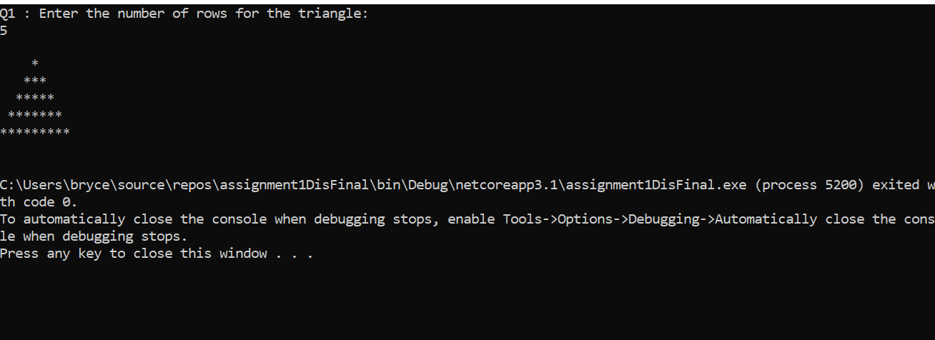

Question 2

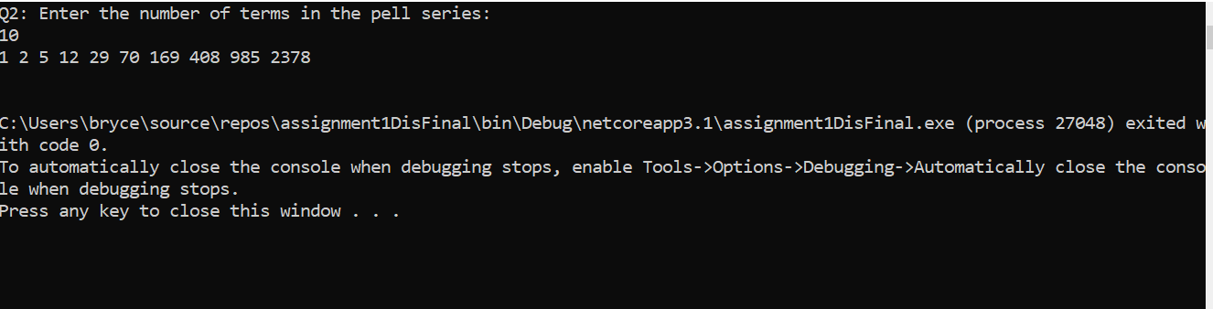

Question 3

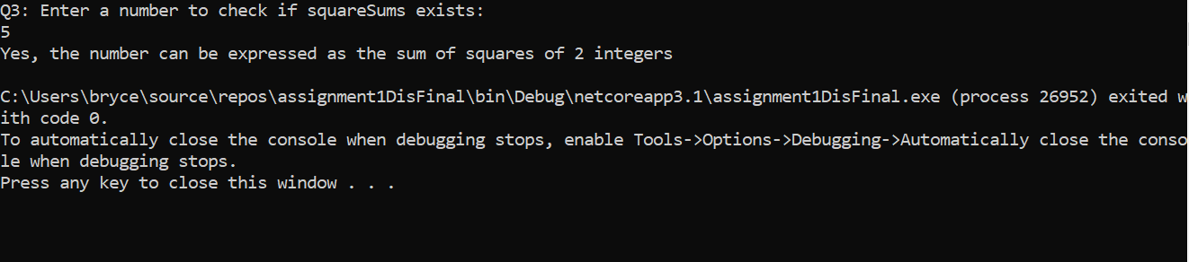

Question 4

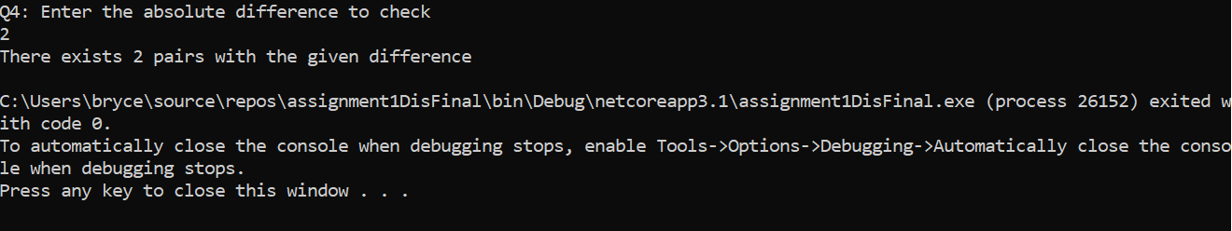

Question 5

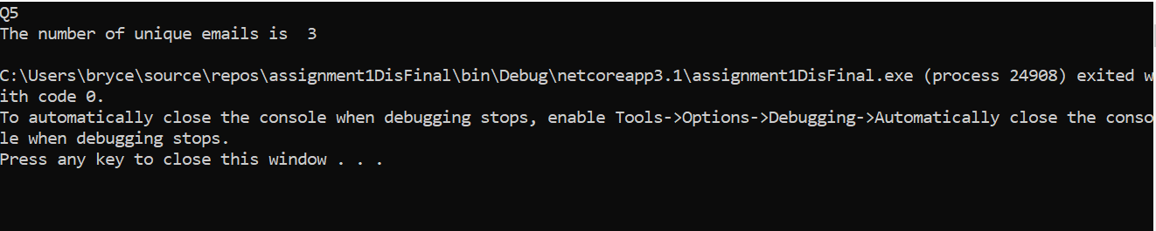

Question 6

